Automatic Face Detection and Recognition for Class Attendance Management System Using Deep Learning Model

This project is submitted to the Department of Computer Science and Engineering at Dhaka International University, in partial to fulfil the requirements of Bachelor of Science (B.Sc.) in the field of computer science and engineering (CSE).

Submitted By

NAME | REG. NO | ROLL NO
Sudipto Sikdar | CS-D-62-20-114075 | 34
Ritam Manan Sarker | CS-D-62-20-114094 | 40
Shayon Halder | CS-D-57-19-111506 | 52
Refat Raihan | CS-D-57-19-111415 | 53
Jannatul Nayeem Labib | CS-D-62-20-123236 – CT | 61
Sk Mohibullah Al Mahin | CS-D-62-20-123282 – CT | 62

Project Work, CSE-425
Batch: D-62 (1st Shift), Session: 2020-2021

Supervised by
Md. Alamgir Hossain
Lecturer



DEPARTMENT OF COMPUTER SCIENCE & ENGINEERING
FACULTY OF SCIENCE AND ENGINEERING
DHAKA INTERNATIONAL UNIVERSITY
DHAKA, BANGLADESH
JANUARY – 2025

SUPERVISOR’S STATEMENT

This is to certify that the project paper entitled as “Automatic Face Detection and Recognition for Class Attendance Management System Using Deep Learning Model” submitted by Sudipto Sikdar, Roll No:- 34; Ritam Manan Sarker, Roll No:- 40; Shayon Halder, Roll No:- 52; Refat Raihan, Roll No:- 53; Jannatul Nayeem Labib, Roll No:- 61; Sk Mohibullah Al Mahin, Roll No:- 62 has been carried out under my supervision. This project has been developed in partial completion of the requirements for the Degree of B.Sc. in Computer Science & Engineering, Department of Computer Science & Engineering, Dhaka International University, Dhaka, Bangladesh.

Supervisor’s Signature

….…..……………………………………………..
Md. Alamgir Hossain
Lecturer
Dept. of Computer Science and Engineering,
Dhaka International University

APPROVAL

The project report titled as “Automatic Face Detection and Recognition for Class Attendance Management System Using Deep Learning Model” submitted by Sk Mohibullah Al Mahin, Jannatul Nayeem Labib, Refat Raihan, Sudipto Sikdar, Shayon Halder, Ritam Manan Sarker, to the Department of Computer Science and Engineering at Dhaka International University, Bangladesh, has been accepted as satisfactory for the partial fulfillment of the requirements for the degree of B.Sc. in Computer Science and Engineering and approved as to its style and contents.
Board of Honorable Examiners
1. Chairman

…………………………………………………..
Md. Tahzib Ul Islam
Associate Professor and Chairman (Acting),
Dept. of Computer Science and Engineering,
Dhaka International University

2. Internal Member

…….…………………………………………….
Prof. Mst. Jahanara Akhtar
Professor,
Dept. of Computer Science and Engineering,
Dhaka International University

3. Supervisor and Member

……………..…………………………………...
Md. Alamgir Hossain
Lecturer
Dept. of Computer Science and Engineering,
Dhaka International University

4. External Member

………………………………….……………….
Dr. Md. Manowarul Islam
Associate Professor,
Dept. of Computer Science and Engineering,
Jagannath University

DECLARATION

We thus declare that we successfully completed this project and submitted it for the granting of the B.Sc. degree. We also confirm that we created this project in order to satisfy the bachelor's degree of Science (B.Sc.) requirements in the field of computer science and engineering.
Authors Signature

……………………………
Shayon Halder
B.Sc. in CSE, Roll No: 52
Reg. No: 111506, Shift: 1st
Batch: 62, Session: 2020-2021
Dhaka International University
……………………………
Refat Raihan
B.Sc. in CSE, Roll No: 53
Reg. No: 111415, Shift: 1st
Batch: 62, Session: 2020-2021
Dhaka International University
……………………………
Sk Mohibullah Al Mahin
B.Sc. in CSE, Roll No: 62
Reg. No: 123282 - CT, Shift: 1st
Batch: 62, Session: 2020-2021
Dhaka International University

……………………………
Ritam Manan Sarker
B.Sc. in CSE, Roll No: 40
Reg. No: 114094, Shift: 1st
Batch: 62, Session: 2020-2021
Dhaka International University
……………………………
Sudipto Sikdar
B.Sc. in CSE, Roll No: 34
Reg. No: 114075, Shift: 1st
Batch: 62, Session: 2020-2021
Dhaka International University
……………………………
Jannatul Nayeem Labib
B.Sc. in CSE, Roll No: 61
Reg. No: 123236 - CT, Shift: 1st
Batch: 62, Session: 2020-2021
Dhaka International University

Supervisor’s Signature

………………………………………………
Md. Alamgir Hossain
Lecturer
Dept. of Computer Science and Engineering,
Dhaka International University
Date: ………………

ABSTRACT

Effective and precise attendance management is essential in contemporary educational institutions; but, conventional approaches such as manual roll calls and sign-in sheets are laborious, prone to errors, and susceptible to fraudulent activities like proxy attendance. This research proposes a deep learning system for automating attendance monitoring using real-time face detection and identification. The proposed Class Attendance Management System (CAMS) uses the YOLOv8 object detection model to identify and recognise student faces in classroom settings. A comprehensive dataset was established by gathering face photographs of students under various settings, including differing lighting, angles, and emotions, with data augmentation methods used to promote variety and optimise model performance. The YOLOv8 model was trained on 80% of the dataset and evaluated on the remaining 20%, with good accuracy (67.9%), precision (97.0%), recall (80.0%), and F1-score (68.0%), so confirming its dependability for practical use. CAMS automates attendance by detecting student presence, identifying faces, and updating records in real-time, while connecting with institutional databases to provide instructors with comprehensive analytics, including attendance trends and personalised reports. Moreover, the system guarantees scalability and flexibility, operating well in classrooms of diverse sizes and configurations. CAMS signifies a substantial improvement in attendance management by removing human involvement, increasing accuracy, and decreasing administrative burden, hence providing a smooth, secure, and effective method for attendance monitoring in contemporary educational institutions.

ACKNOWLEDGEMENTS

We would want to offer our appreciation to the Almighty Allah, who created us with not only the capacity to develop and program this system but also the power of practice.

We would also want to offer our heartfelt appreciation to our renowned supervisor, Md. Alamgir Hossain, Lecturer, Dept. of the CSE, Dhaka International University, for his continual support, inspiration, and professional advice throughout the development of this project.

We would like to thank all the faculty members for their considerable effort spent on requirements analysis and assessment of the project work.

We would like to convey our genuine and warm appreciation to the individuals who have helped us personally and supplied mental encouragement. We are also appreciative to our family and friends who contributed directly or indirectly to the development of the word and its connected activities.

We sincerely appreciate Md. Tahzib Ul Islam, Associate Professor and Chairman (Acting), the Dept. of Computer Science and Engineering, and Mst. Jahanara Akhtar, Professor, Dept. of Computer Science and Engineering at Dhaka International University, for their useful advice and moral support. Their thorough conversation around work and intriguing inquiry in operations has been really useful for our project.

Finally, we would want to dedicate our project to our professors for their love, support, and professional assistance during the project.

Dedicated to
Our Parents
&
Teachers

LIST OF CONTENTS
ABSTRACT . . . . . . . . . . . . . . . . . . . . . . . .. . . . . . . . . . . . . . . . . . . . . . . |  |  |  | i
ACKNOWLEDGMENTS . . . . . . . . . . . . . . . . . . . .. . . . . . . . . . . . . . . |  |  |  | ii
DEDICATION. . . . . . . . . . . . . . . . . . . .. . . . . . . . . . . . . . . . . . . . . . . . . |  |  |  | iii
LIST OF CONTENTS. . . . . . . . . . . . . . . . . . . .. . . . . . . . . . . . . . . . . . . |  |  |  | iv
LIST OF FIGURES . . . . . . . . . . . . . . . . . . . .. . . . . . . . . . . . . . . . . . . . |  |  |  | vi
LIST OF TABLES . . . . . . . . . . . . . . . . . . . .. . . . . . . . . . . . . . . . . . . . . |  |  |  | vii
LIST OF ALGORITHMS . . . . . . . . . . . . . . . . . . . .. . . . . . . . . . . . . . . |  |  |  | viii
1 | Introduction |  |  |  |  | 1-3
 | 1.1 | Preamble . . . . . . . . . . . . . . . . . . . .. . . . . . . . . . . . . . . . . . . . . . . . . |  |  |  | 1
 | 1.2 | Motivation . . . . . . . . . . . . . . . . . . . . . . . . . . . . . . . . . . . . . . . . . . . |  |  |  | 2
 | 1.3 | Contribution . . . . . . . . . . . . . . . . . . . . . . . . . . . . . . . . . . . . . . . . . . |  |  |  | 3
 | 1.4 | Thesis organization . . . . . . . . . . . . . . . . . . . . . . . . . . . . . . . . . . . . |  |  |  | 3
2 | Literature Review |  |  |  | 4-10
 | 2.1 | Faster R-CNN Model . . . . . . . . . . . . . . . . . . . . . . . . . . . . . . . . . . . |  |  |  | 4
 | 2.2 | YOLOv3-Tiny. . . . . . . . . . . . . . . . . . . . . . . . . . . . . . . . . . . . . . . . . |  |  |  | 6
 | 2.3 | YOLOv4 . . . . . . . . . . . . . . . . . . . . . . . . . . . . . . . . . . . . . . . . . . . . . |  |  |  | 7
 | 2.4 | YOLOv5 . . . . . . . . . . . . . . . . . . . . . . . . . . . . . . . . . . . . . . . . . . . . . |  |  |  | 8
 | 2.5 | YOLOv6 . . . . . . . . . . . . . . . . . . . . . . . . . . . . . . . . . . . . . . . . . . . . . |  |  |  | 9
 | 2.6 | YOLOv7 . . . . . . . . . . . . . . . . . . . . . . . . . . . . . . . . . . . . . . . . . . . . . |  |  |  | 10
3 | Problem Statement |  |  |  |  | 11-12
 | 3.1 | Explanation of the Problem Statement . . . . . . . . . . . . . . . . . . . . . . |  |  |  | 11
 | 3.2 | Objectives . . . . . . . . . . . . . . . . . . . . . . . . . . . . . . . . . . . . . . . . . . . . |  |  |  | 11
4 | Research Methodology |  |  |  |  | 13-18
 | 4.1 | Methodology Introduction. . . . . . . . . . . . . . . . . . . . . . . . . . . . . . . |  |  |  | 13
 | 4.2 | Dataset Preparation . . . . . . . . . . . . . . . . . . . . . . . . . . . . . . . . . . . . |  |  |  | 14
 | 4.3 | Image pre-processing and Augmentation Process . . . . . . . . . . . . . |  |  |  | 16
 | 4.4 | Target Face Object Labelling . . . . . . . . . . . . . . . . . . . . . . . . . . . . . |  |  |  | 17
5 | Proposed Face-YOLOv8 Model Analysis |  |  |  |  | 19-22
 | 5.1 | Principal of YOLO . . . . . . . . . . . . . . . . . . . . . . . . . . . . . . . . . . . . |  |  |  | 19
 | 5.2 | Analysis of Face-YOLOv8 . . . . . . . . . . . . . . . . . . . . . . . . . . . |  |  |  | 19
 | 5.3 | The Backbone network . . . . . . . . . . . . . . . . . . . . . . . . . . . . . . . . |  |  |  | 21
 | 5.4 | The Neck network . . . . . . . . . . . . . . . . . . . . . . . . . . . . . . . . . . . . |  |  |  | 21
 | 5.5 | The Head network . . . . . . . . . . . . . . . . . . . . . . . . . . . . . . . . . . . . |  |  |  | 21
 | 5.6 | The Algorithm of Face-YOLOv8 model . . . . . . . . . . . . . . . . . |  |  |  | 22
6 | Result and Discussion |  |  |  |  | 23-25
 | 6.1 | Training Experiments . . . . . . . . . . . . . . . . . . . . . . . . . . . . . . . . . . |  |  |  | 23
 | 6.2 | Proposed Model Evaluation Matrices . . . . . . . . . . . . . . . . . . . . . . |  |  |  | 23
 | 6.3 | Training and Testing Performance Analysis . . . . . . . . . . . . . . . . . |  |  |  | 24
 | 6.4 | Face Classification and Detection Performances . . . . . . . . . . . |  |  |  | 25
7 | Conclusion and Future Work |  |  |  |  | 29
 | 7.1 | Conclusion . . . . . . . . . . . . . . . . . . . . . . . . . . . . . . . . . . . . . . . . . . . |  |  |  | 29
 | 7.2 | Future Work . . . . . . . . . . . . . . . . . . . . . . . . . . . . . . . . . . . . . . . . . . |  |  |  | 29
 | References . . . . . . . . . . . . . . . . . . . . . . . . . . . . . . . . . . . . . . . . . . . . . . . . |  |  |  |  | 30

List of Figures
Fig. 1 | Taking class photos with all students present . . . . . . . . . . . . . . . . | 1
Fig. 2 | Faster R-CNN architecture model . . . . . . . . . . . . . . . . . . . . . . . . . | 5
Fig. 3 | The architecture of YOLOv3-tiny model . . . . . . . . . . . . . . . . . . . . | 6
Fig. 4 | The architecture of YOLOv4 model . . . . . . . . . . . . . . . . . . . . . . . . | 7
Fig. 5 | The architecture of YOLOv5 model . . . . . . . . . . . . . . . . . . . . . . . . | 8
Fig. 6 | The YOLOv6 model architecture . . . . . . . . . . . . . . . . . . . . . . . . . . | 9
Fig. 7 | The YOLOv7 model architecture . . . . . . . . . . . . . . . . . . . . . . . . . . | 10
Fig. 8 | Overall research methodology flowchart . . . . . . . . . . . . . . . . . . . . | 13
Fig. 9 | Collected some images . . . . . . . . . . . . . . . . . . . . . . . . . . . . . . . . . . | 15
Fig. 10 | Augmentation images . . . . . . . . . . . . . . . . . . . . . . . . . . . . . . . . . . . | 17
Fig. 11 | Object labelling file as YOLO format . . . . . . . . . . . . . . . . . . . . . . | 18
Fig. 12 | Proposed Face-YOLOv8 architecture model . . . . . . . . . . . . . . . . . | 20
Fig. 13 | Training results . . . . . . . . . . . . . . . . . . . . . . . . . . . . . . . . . . . . . . . | 25
Fig. 14 | Face detection and classification results . . . . . . . . . . . . . . . . . . . . | 26
Fig. 15 | Confusion matrix of the proposed model . . . . . . . . . . . . . . . . . . . | 27
Fig. 16 | False positive detecting results by the YOLOv8 model, where one detected as another name from a still image and the other one couldn’t detect face . . . . . . . . . . . . . . . . . . . . . . . . . . . . . . . . . | 28

List of Tables

Table 1 | Collected Student image Dataset description. . . . . . . . . . . . . | 15

List of Algorithms

Algorithm 1 | The proposed YOLOv8 face detection model algorithm . . . . | 22

Chapter 1 | INTRODUCTION

1.1 PREAMBLE
Attendance management is a crucial aspect of academic administration, ensuring student engagement and accountability. Traditional methods, such as manual roll calls or sign-in sheets, are not only time-consuming but also susceptible to errors like proxy attendance and missed entries. These inefficiencies hinder educators from maintaining accurate records and identifying trends effectively.
The "Automatic Face Detection and Recognition for Class Attendance Management System Using Deep Learning Model" leverages advancements in artificial intelligence, particularly YOLOv8, a state-of-the-art deep learning model for object detection. This system automates attendance tracking by capturing student images in real-time during class sessions, detecting and recognizing faces, and marking attendance with high accuracy. The system securely stores attendance data in a digital database, providing easy access for analysis and reporting.
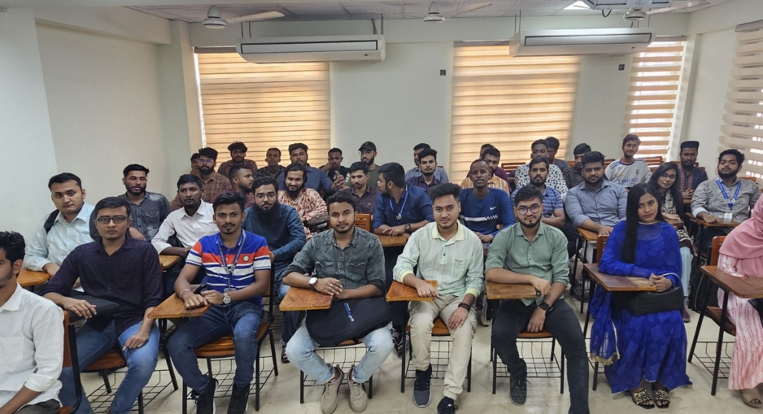
By integrating deep learning technology, the system minimizes administrative workloads, eliminates errors associated with manual processes, and enhances the overall efficiency of attendance management. It represents a step forward in modernizing academic operations and ensuring a seamless learning environment.

Figure 1: Taking class photos with all students present

1.2 MOTIVATION
In modern educational environments, ensuring accurate and efficient attendance management has become increasingly challenging. Traditional methods, such as roll calls or sign-in sheets, are not only labor-intensive but also prone to issues like human error, proxy attendance, and difficulties in maintaining long-term records. These limitations hinder educators from effectively monitoring student engagement and identifying attendance trends, which are critical for improving academic outcomes.
The advent of artificial intelligence, particularly in the field of computer vision, presents a transformative opportunity to address these challenges. With its ability to process vast amounts of visual data quickly and accurately, AI-powered solutions can automate routine tasks while maintaining high levels of precision. Face detection and recognition technologies, in particular, have proven to be reliable tools for identifying individuals in real-time scenarios, making them ideal for attendance management applications.
The motivation for this project stems from the need to bridge the gap between traditional methods and modern technological advancements. YOLOv8, a cutting-edge deep learning model, offers exceptional real-time detection capabilities, making it an ideal choice for developing an automated attendance system. Unlike earlier versions, YOLOv8 provides improved detection speed, accuracy, and scalability, allowing it to handle diverse classroom environments with varying lighting conditions, seating arrangements, and student demographics.
Additionally, the adoption of such a system aligns with the broader goals of digital transformation in education. By automating attendance tracking, educators can focus more on teaching and less on administrative tasks. The system also provides institutions with valuable insights into attendance patterns, enabling data-driven decisions to enhance student engagement and academic performance.
This project is further motivated by the potential to eliminate common challenges such as lost attendance records, proxy marking, and time wastage during manual roll calls. It also seeks to set a benchmark for integrating AI-driven solutions into education, demonstrating how cutting-edge technologies can enhance operational efficiency and improve overall learning experiences.

1.3 CONTRIBUTION
This research work makes the following key contributions:
- A novel face detection and recognition model (YOLOv8) is proposed, specifically designed for class attendance management.
- Real-time student images were collected from classroom environments to develop a unique dataset for training and testing the model.
- The proposed system processes images in real-time, automatically marking attendance and storing the data in a secure digital format.
- The proposed system is evaluated against state-of-the-art object detection models, highlighting its accuracy, efficiency, and scalability for class attendance scenarios.

1.4 PROJECT ORGANIZATION
The thesis is organized as follows: Chapter 2 includes a literature overview, reviewing relevant studies and current attendance management methods, including YOLO-based object identification algorithms, their constraints, and research needs. Chapter 3 highlights the problems of conventional attendance systems and explains the aims of the suggested alternative. Chapter 4 discusses the study methods, encompassing dataset preparation, pre-processing methods, augmentation, and picture labeling, along with a guide to the YOLOv8 model structure. Chapter 5 discusses the system's setup and analysis, covering the design of the YOLOv8-based method, including its foundation, neck, and head elements, as well as methods, processes, and performance indicators. Chapter 6 includes a complete examination of the model via training trials, accuracy measurements, and comparisons with current approaches, bringing knowledge about performance analysis. Finally, Chapter 7 reviews the research contributions, examines its significance, and offers future modifications for scalability and new features.

Chapter  2 | LITERATURE REVIEW

In this chapter, we will apply several classification approaches, including Faster R-CNN, YOLOv3-Tiny, YOLOv5, YOLOv6 and YOLOv7 to conduct vehicle detection and identification. Face identification and recognition have garnered substantial appeal as a notable study subject in the science of computer vision. Algorithms for face identification and recognition tend to rely on high-performance techniques that promote accuracy and efficiency.

2.1 Faster R-CNN Model
The Faster Region-based a convolution neural network (Faster R-CNN) [12] is a deep convolutional network that is used for object recognition and appears to users as a single network. It includes a region-proposal networks (RPN), which creates region suggestions for object inspection using the Fast R-CNN identification model. This model is an enhancement of Fast R-CNN [13]. In the Faster R-CNN architecture, the RPN is accountable for providing region suggestions that are subsequently processed by a configurable network tailored to the detection job at hand. Each area in the picture performs ROI The combination [13] to obtain a fixed-length vector of features. Then, Fast R-CNN takes advantage of these vectors of features for identifying objects and gives their associated box boundaries, along with the classification results. The Faster R-CNN system is depicted in Figure 2. Regional Proposal Networks (RPNs) provide an efficient and accurate technique to producing region suggestions. The region proposal process is very efficient due to the common convolutional features and the ensuing detection network.
This enables for the smooth integration of a sophisticated object identification system built around deep learning, yielding astonishing rates of 5-17 images per second (fps). Furthermore, the RPN's learning skills boost the quality of region recommendations, hence enhancing the general precision of object identification.
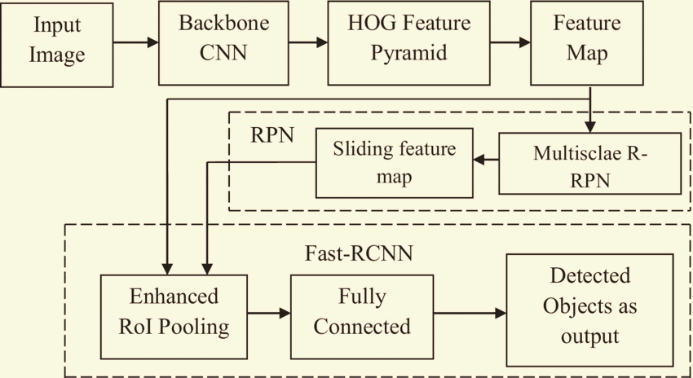

Figure 2: Faster R-CNN Architecture Model

An upgraded form of the Faster R-CNN method, which adds a narrowing approach, is provided to boost the accuracy of watercraft identification while lowering the method's detection time. The disadvantage of faster R-CNN is that it uses a single image to train the RPN, which uses all of the 256-bit mini-batch anchors. The network can require an extended period to obtain convergence as all samples from one image may be related (i.e., have same features).

2.2 YOLOv3-Tiny
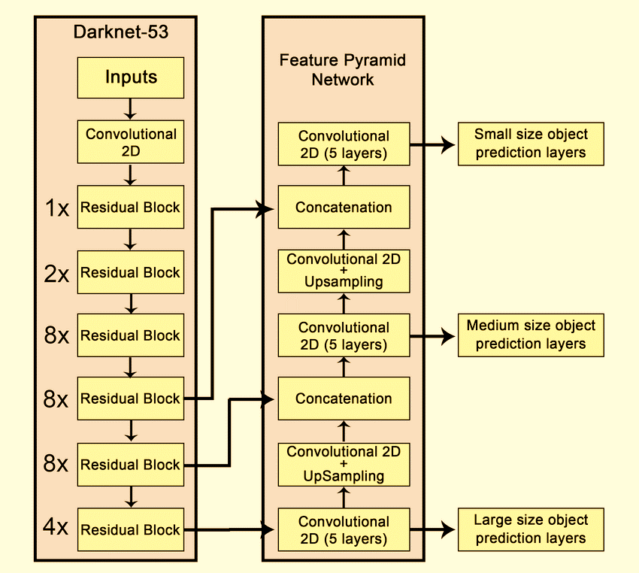
The YOLOv3-Tiny is a customised version of YOLOv3, suggested by Joseph Redmon in [14], for identifying objects, which makes it suited for applications that operate in real time on devices featuring low processing capabilities, including mobile devices or systems that are embedded. Tiny-YOLOv3's structure is comprised up of two completely connected layers after the 23 layers of convolution. YOLOv3-Tiny utilises pooling layers and minimises the number of layers used for convolution. The model accepts an input picture with a set size, generally 416x416 pixels. It predicts a three-dimensional tensor containing class predictions at two unique scales, boundary box supervises, and objectness ratings. The picture is partitioned into a grid of the cells, and to evaluate the final detections, box boundaries with the objectness values are evaluated. YOLOv3-Tiny employs convolutional neural network and layers with maximum pooling in a feedforward configuration to extract features. Bounding box predictions are produced on two separate feature map scales: 13x13 and 26x26, which are subsequently blended with an upsampled 13x13 map of features [15]. The architectural diagram of Tiny-YOLOv3 show in Figure 3. The increased risk of accidents with mining trucks is owing to their massive size, high height, and broad breadth, which result in considerable blind areas and long braking distance. The Tiny-YOLOv3 approach, which delivers high performance in real time but falling short when it comes of precision for detection, is employed in the study to discover obstructions in the mine. By introducing an additional network architecture built around convolutional neural networks (CNN), an improved target recognition system based on Tiny-YOLOv3 was constructed to get around this problem. The accuracy is enhanced from 62.0% - 66.5% [16].

Figure 3: The architecture of YOLOv3-tiny model

But YOLOv3 gets acquainted with bigger things; it may fail to reliably distinguish similar objects on smaller sizes. YOLOv3 may not be the optimum solution when it comes to properly deploying specialized models in cases where getting huge datasets is problematic.

2.3 YOLOv4
The YOLOv4 architecture shows in the Figure 4. A recent development in face identification and classification is the YOLOv4 model, which was produced by refining the YOLOv4 model. It contains a compact convolutional block attention module (CBAM) that was first demonstrated in [17]. This module boosts the model's capacity to identify relevant aspects within the photos. CBAM consisting of two modules, notably the channel attention module (CAM) and the spatial attention module (SAM). These modules may be ordered in either parallel or sequentially. The CAM focuses on retrieving distinct feature knowledge, whereby each channel of the characteristics functions as a specialized sensor. In contrast to this, the SAM mixes the channel descriptions created by average pooling and maximal accumulating, which are subsequently put through to a neural layer's process in order to derive weight coefficients. In the grand scheme of things, CBAM is a user-friendly approach that can be trained from end to end & is straightforward to incorporate into any a convolutional neural network, architecture.

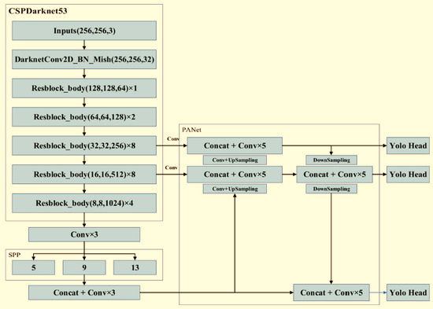

Figure 4: The architecture of YOLOv4 model

2.4 YOLOv5
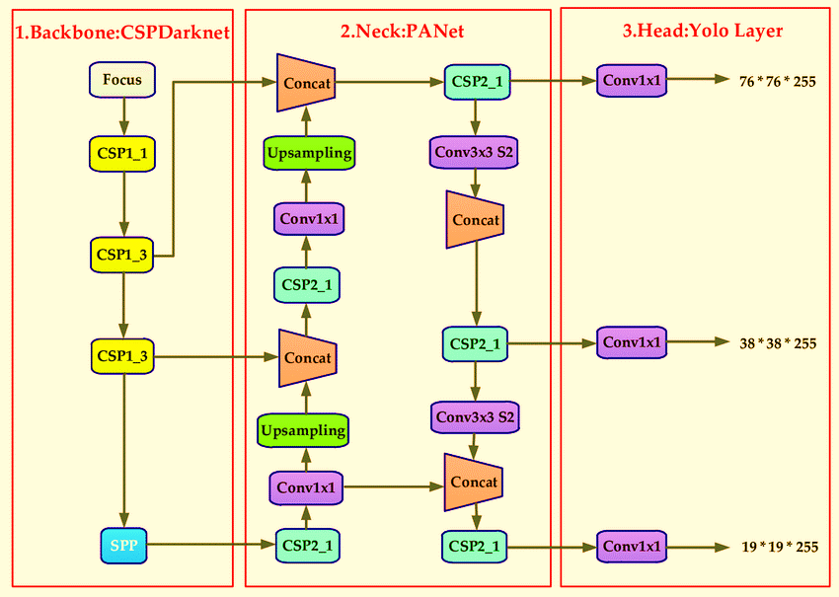
A more modern model in the YOLO family, the YOLO-v5 is renowned for its accurate object detection [20]. There are many variations of YOLO-v5, including YOLO-v5s, YOLO-v5m, YOLO-v5l, and YOLO-v5x. These variations differ in terms of size and inference time. The head, neck, and backbone are the three primary parts of the YOLO-v5 design, as shown in Figure 5 [19]. The foundation of YOLO-v5 is made up of Cross Stage Partial (CSP) networks, which are utilised to extract important features from the input image. Figure 5 displays the specifications of the core modules. The neck module is responsible for generating a feature pyramid utilising the PAN (Path Aggregation Network) technique, which gathers features for subsequent processing. The characteristics of the neck module and its integrated components are presented in Figure 5. The head block uses anchor boxes to generate predictions in order to identify objects. YOLOv5 employs transfer learning to boost its intelligence. This approach uses convolutional layers to examine an input dataset before sending it to fully connected (FC) layers. After processing test datasets, pre-trained networks generate the final output via the FC layers.

Figure 5: The architecture of YOLOv5 model
Figure 5 depicts the transfer learning technique used by YOLOv5, in which pre-trained networks process the test datasets to produce the final output, while convolutional and FC layers process the input dataset. For high-quality optical remote sensing photos, an updated YOLOv5 object recognition method has been developed. It uses a multi-detection-head approach, a hybrid attention module, and many layers of the feature pyramid to enhance the detection impact. The algorithm's Overall Accuracy score is 81.51% [20]. The shortcoming of the YOLOv5s concept indicates lower accuracy when it involves recognising tiny items inside congested surroundings [21].

2.5 YOLOv6
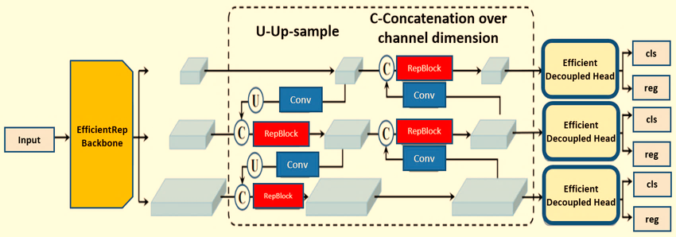
The YOLOv6 models use a number of state-of-the-art techniques designed to balance accuracy and speed. Similar to previous models, YOLOv6 is composed of three fundamental components: the Head, Neck, and Backbone. Each component adds new features and enhancements. YOLOv6 is noteworthy for its reparameterized backbone and anchor-free idea, both of which are important advancements. Figure 6 shows the YOLOv6 object recognition model's whole architecture. To enhance speed, the YOLOv6 models incorporate reparameterized backbones. Reparameterization requires altering the network topology throughout all the training & inference phases. The neck component of YOLOv6 utilizes PAN (Path Aggregation Networks) to combine multi-scale feature maps.
Reparametrized PAN, also known as Rep-PAN, is a modified form of PAN that is improved in YOLOv6 by concatenating features from different reparameterized blocks. Moreover, YOLOv6 makes use of an Efficient Separated Head design, in which both the detection and classification branches operate independently of the main system and have distinct characteristics.

Figure 6: YOLOv6 model architecture
This case study suggests creating a dynamic detection model that uses the YOLOv6 method to identify individuals who are not wearing face masks in accordance with COVID-19 prevention guidelines. The real-time deployment of the suggested strategy drove a 36% increase in wearing masks compliance among the observed audience, helping to avoiding the further propagation of COVID-19. The model’s success percentage is 97.9% [22]. But YOLOv6 demonstrates a lack of reliability and offers a somewhat greater degree of complexity in terms of usage.

2.6 YOLOv7
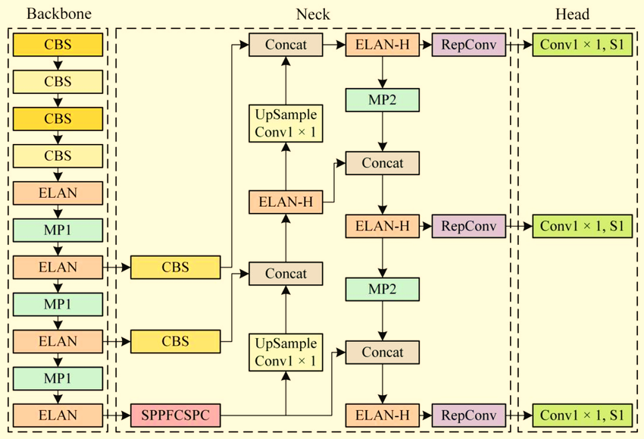
Through a number of novel features, the YOLOv7 model balances speed and accuracy to provide state-of-the-art performance in object detection. YOLOv7 is organised into three primary parts, same like its predecessors: the Head, Neck, and Backbone. The Cross Stage Partial Network (CSPNet) serves as the foundation for the Backbone, which partitions feature maps and makes use of important innovations like Dynamic Label Assignment (DLA), which assigns training labels dynamically to increase adaptability, and E-ELAN, which improves learning through expanded layer collection, to extract features efficiently. The Neck collects multi-scale features utilising the principle of the Path Aggregation Network (PAN) topology, promoting bidirectional feature flow & increasing detection using Reproduced CSP & Multi-Scale Feature Fusion. Classification and localisation are handled by the Head, which uses a decoupled head architecture to better optimize these processes and lessen reliance on pre-defined anchor boxes by using an anchor-free approach. Key advancements in YOLOv7 includes model scaling techniques for width, depth, and solution, adaptable modules for customisation, efficient GPU use during training, and an enhanced accuracy-speed compromise, making it perfect for real-time applications. Its uses include recognition of faces, industrial quality control, autonomous vehicle navigation, and actual time recognition of objects in surveillance systems. Performance benchmarks reveal that YOLOv7 beats YOLOv6 and earlier versions in speed and accuracy, reaching greater average precision (mAP), and better frames per second (FPS) owing to its streamlined design.

Figure 7: YOLOv7 model architecture

Chapter 3 | PROBLEM STATEMENT

3.1 Explanation of the Problem Statement
Class attendance is an important feature of academic environments, acting as a major metric of student interest and participation. Yet, physical roll calls and sign-in sheets-two of the most antiquated techniques for documenting attendance- 0.223438 0.223438 are laborious, ineffective, and prone to mistakes. These antiquated systems can lead to difficulties like vicarious attendance, when students incorrectly claim attendance for missing colleagues, undermining the veracity of participation statistics. Additionally, manual roll calls occupy important class time that may be better employed for education or discussion. Professors and administrators confront substantial obstacles in keeping accurate records, creating reports, and correcting mistakes, further adding to their burden. Over time, the manual administration of attendance records becomes laborious and subject to data loss, making it impossible to access prior data effectively. As class sizes expand and educational institutions turn toward data-driven decision-making, the necessity for a dependable, automated attendance system becomes more critical. The face detection and recognition technologies brought about by deep learning and computer vision advancements have shown promise, but a number of issues still exist, such as the need for seamless integration with current academic databases and infrastructure, the high computational demands of real-time processing in large classrooms, and the variability of classroom environments caused by shifting lighting, different seating arrangements, and different facial angles. To overcome these restrictions, this research presents an Automatic Face Detection and Recognition for Class Attendance Management System Using Deep Learning Model employing YOLOv8, a state-of-the-art object identification model designed for real-time performance. YOLOv8’s speed and precision make it well-suited for dynamic classroom environments, providing rapid and exact attendance monitoring. The suggested system intends to expedite attendance procedures, boost record accuracy, give actionable insights, and minimize the administrative load on instructors.

3.2 Objectives
This project seeks to build Attendance-YOLOv8, a sophisticated face detection and identification system that employs YOLOv8’s real-time, high-accuracy capabilities to automate student attendance marking. The model will be customized for varied classroom contexts, guaranteeing dependable performance under changing lighting conditions, seating configurations, and face angles. To boost accuracy, a complete collection of student face photos will be gathered and annotated, including diverse lighting intensities, angles, and classroom configurations. Data augmentation approaches will be utilized to increase model resilience against real-world variability. The technology will completely automate attendance monitoring by detecting and identifying students' faces in real time, securely collecting attendance data in a database, and integrating smoothly with current academic infrastructures such as Learning Management Systems (LMS). Additionally, the system will create extensive attendance statistics, allowing educators and administrators insights into student attendance habits, including trends, absences, and punctuality, enabling data-driven interventions to boost engagement and performance. Designed for scalability, the system will fit classrooms of various sizes, from tiny tutorials to big lecture halls, while assuring data security and compliance with institutional standards to preserve student privacy. Finally, the system will undergo rigorous real-world testing in actual classroom contexts to assess accuracy, efficiency, and flexibility, with results contrasted against current attendance management approaches to illustrate its benefits.

Chapter 4 | METHODOLOGY

4.1 Methodology Introduction
The explanation of study methodology, picture dataset creation, pre-processing, the augmentation procedure, and the suggested YOLOv8-based face detection and identification model are covered in this part. The whole technique flow diagram is presented in Figure 8. This work employs face photos acquired from actual classroom contexts to construct an autonomous attendance management system. The proposed model is trained using pre-processed photos with annotated face data in YOLO format. The gathered face photos are sorted into several student identities for correct identification. Various data augmentation approaches, including as rotation, flipping, and brightness modifications, are utilised to boost model resilience against variations in illumination, occlusions, and posture discrepancies. The technology is intended to identify and recognize faces with high precision, enabling an efficient and reliable attendance monitoring procedure for educational institutions.

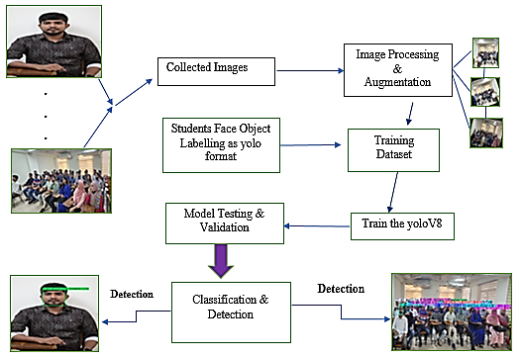

Figure 8: Overall research methodology flowchart

4.2 Dataset Preparation
This study utilizes a real-time face picture dataset acquired from classroom situations with the agreement of the relevant universities. Various face photos of students were obtained using a high-resolution DSLR camera and smartphone cameras under diverse lighting situations and angles to guarantee dataset variety. Initially, 1,000 face pictures were gathered to construct the initial dataset. A thorough breakdown of the dataset is presented in Table 1. Each picture was acquired at a resolution of 1080 × 2340 pixels, with supplemental video footage shot at 4K@60 fps for data improvement. The acquired photos underwent pre-processing techniques such as scaling, normalization, and noise reduction, followed by data augmentation methods including rotation, flipping, and brightness modification to increase model generalization. The YOLOv8 model was trained on 7,500 photos, with 80% utilized for training and 20% for testing. Additionally, 20% of the training samples were put aside for validation to minimize overfitting. For clarity, some face photos from the dataset are displayed in Figure 9.
  (a) |   (b)
  (c) |   (d)
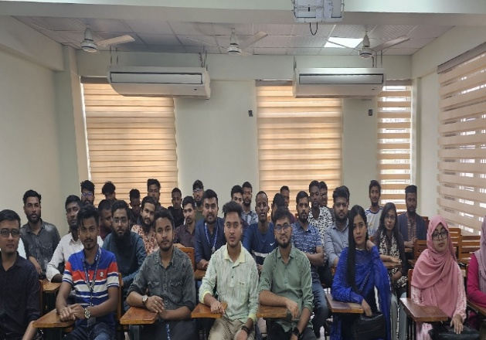  (e) | 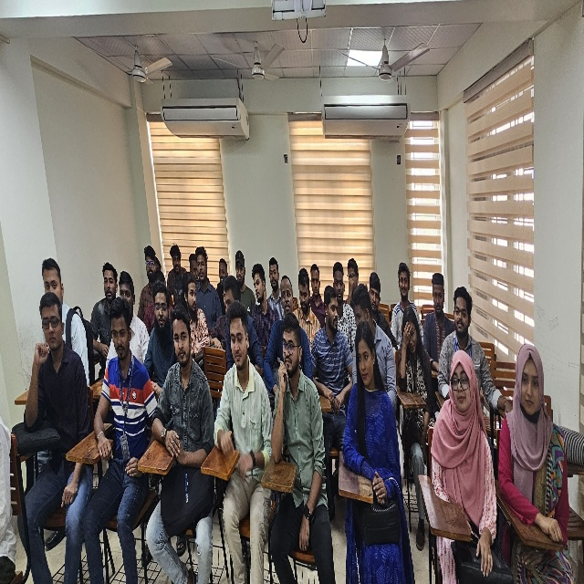  (f)
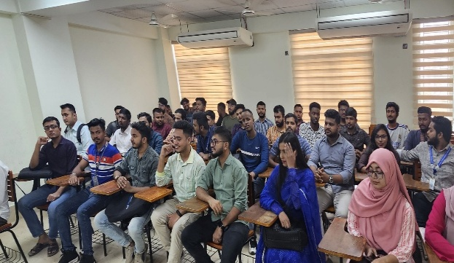  (g) | 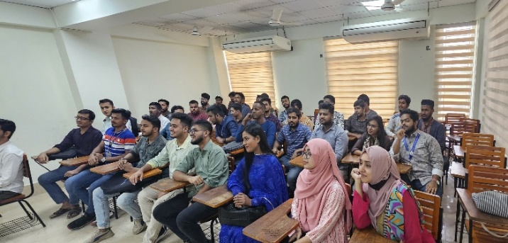  (h)

Figure 9: Collected some images – Single image (a, b, c, d) & Group image (e, f, g, h)

Table 1. Collected Student images dataset Description
No. of Images | Images per Group and Single | Augmented Images | Training dataset
No. of Images | Images per Group and Single | Augmented Images | Training images (80%) | Validation images  (20%) | Testing images  (20%)
Group Photos | 62 | 156 | 781 | 133 | 26
Single photos | 214 | 482 | 781 | 133 | 26
Total | 276 | 539 | 781 | 133 | 26

4.3 Image pre-processing and Augmentation Process
In deep learning-based face detection and identification models such as YOLOv8, picture pre-processing is essential to guarantee consistent input dimensions and improve model efficacy. The proposed model requires an input picture dimension of 640×640 pixels, hence all acquired facial images were preprocessed and downsized suitably prior to training. Due to the dataset's original scarcity of facial photos, augmentation methods were used to provide a more extensive training set and enhance the model's efficacy in practical applications.

This research included eight picture augmentation techniques: rotation, scaling, translation, width shifting, height shifting, horizontal flipping, vertical flipping, and zooming. These strategies were systematically used to each facial picture to generate many variants, hence enhancing dataset variety. Rotation facilitates recognition from diverse perspectives, while scaling guarantees flexibility to varying face sizes. Translation, width modification, and height modification enhance robustness by adjusting picture placement. Horizontal and vertical flips facilitate face detection irrespective of orientation, while zooming improves the model's capacity to identify facial characteristics at varying distances.

The dataset was augmented to 1,000 images, therefore greatly boosting generalization, mitigating overfitting, and improving the accuracy of real-time face identification and recognition for class attendance management.
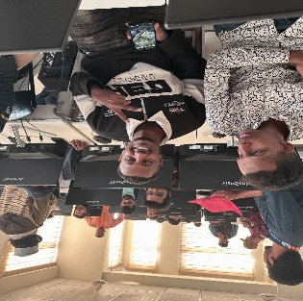  (a) | 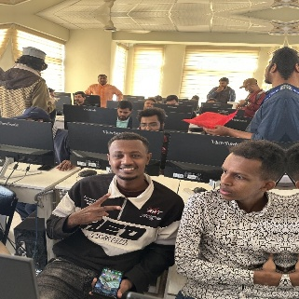  (b) | 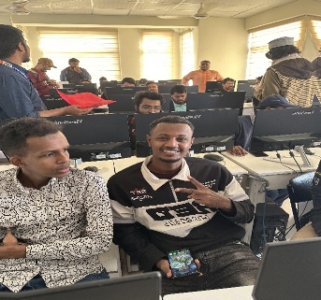  (c)
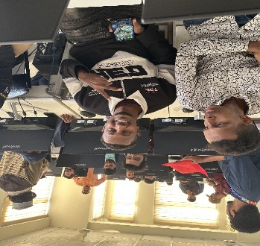  (d) | 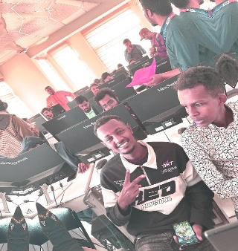  (e) | 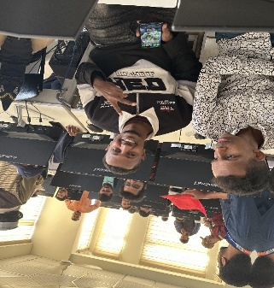  (f)
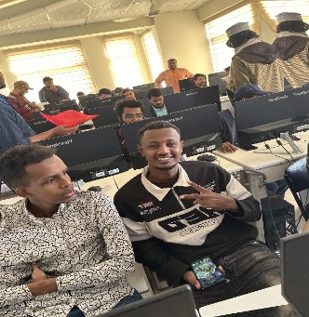  (g) | 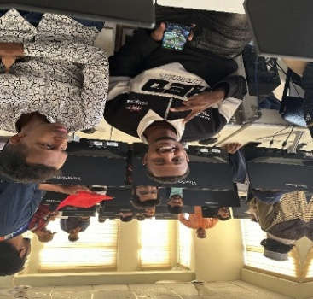  (h) | 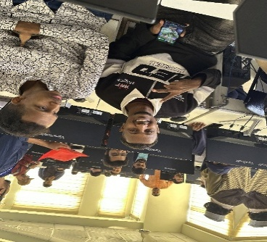  (i)

Figure 10: Augmentation Images – Rotation (a, d, f, h), Flipping(b), Straight(c, i) and Brightness(e)

4.4 Target Face Object Labelling
To train the YOLOv8 model for automated face identification and recognition, it is required to identify the face objects in the picture collection appropriately. The LabelImg program was used to label each face in the training and validation datasets, yielding YOLO format files for fast model training.

A YOLO format file is a text file that provides key information about each identified face, including the class ID, center coordinates (x0, y0), and bounding box dimensions (width w, height h). This organized framework helps the model to learn face detection patterns successfully. Since the dataset focuses on facial recognition for class attendance, each identified face is labeled identically, guaranteeing precise identification.

For example, in the YOLO format, a face class ID is assigned as “0” for identified faces in Figure 11. Each face object’s specific bounding box coordinates and dimensions are maintained in the YOLO annotation files, enabling the YOLOv8 model to quickly identify and recognize pupils in real-time classroom scenarios.
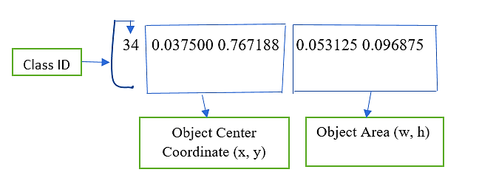  (a) | 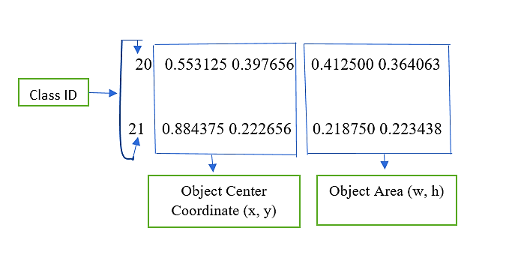  (b)
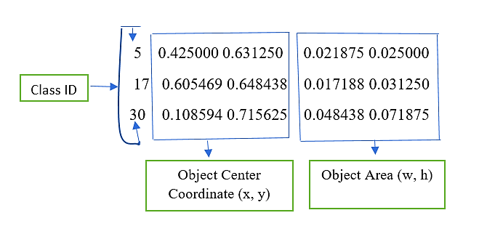  (c) | 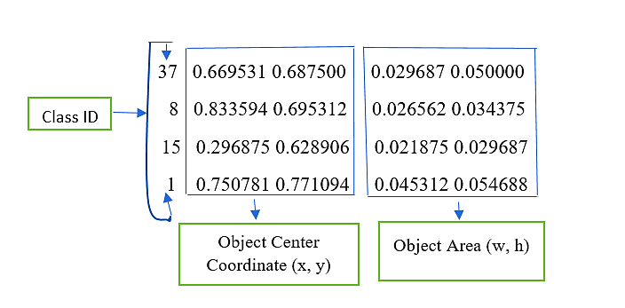  (d)

Figure 11: Object labelling file as YOLO format – (a) Single person, (b) Double person, (c) Triple person and (d) Four person

CHAPTER  5 | PROPOSED IMAGE DETACTION-YOLOV8 MODEL ANALYSIS

5.1 Principal of YOLO
One of the most contemporary concepts is YOLO (You only look once) approaches for real-time object detection established by Joseph Redmon and others Classifiers have been utilized in the past to accomplish object detection [24]. As an alternative, view object recognition as a regression problem to spatially discrete bounding boxes and associated class probabilities. Direct prediction of bounding boxes and class probabilities by a single neural network entire pictures in a single evaluation. Since the whole detection pipeline consists of a single network, detection performance may be modified from beginning to finish [25]. Fast YOLO, a scaled-down version of the network, processes only 155 frames per second while still beating other real-time detectors in mAP by a factor of two. Modern detection algorithms don't make as much localization as YOLO does [25].

5.2 Analysis of Proposed Vehicle-YOLOv7 Model
YOLO (You Only Look Once) is one of the most powerful real-time object identification algorithms, developed for speed and accuracy in finding objects inside photos and videos. In 2023, YOLOv8 was announced as an updated version of its predecessors, including better accuracy, efficiency, and flexibility for diverse object detection tasks, including face detection and identification.
The YOLOv8 model comprises of many deep learning components, including convolutional layers, pooling layers, and fully connected layers, which work together to identify and recognize faces in real-time. It utilizes anchor-free detection, adaptive learning algorithms, and an improved loss function, making it more efficient for face identification than prior YOLO versions. The model separates an input picture into a grid, predicts bounding boxes, confidence scores, and class probabilities to identify and locate faces properly.
In this work, the YOLOv8 model, referred to as Face-YOLOv8, was applied for automated face detection and identification in a classroom scenario. The suggested architecture comprises of three primary components: (i) Backbone, (ii) Neck, and (iii) Head (Prediction Layer). Each component plays a key role in enhancing feature extraction, refining detection accuracy, and boosting classification performance.
One of the key breakthroughs in YOLOv8 is the usage of anchor-free detection, which streamlines the detection process by removing specified anchor boxes. This helps the model to recognize faces of varied sizes and orientations more effectively. Additionally, a novel loss function, dubbed Distribution Focal Loss (DFL), boosts accuracy, especially for tiny face identification, by concentrating on difficult-to-detect faces while decreasing false positives. YOLOv8 additionally supports high-resolution picture processing (640×640 pixels), which considerably increases face recognition accuracy.
The Backbone of the Face-YOLOv8 model is based on the CSPDarknet framework, intended to extract rich face characteristics quickly. The Neck incorporates Path Aggregation Network (PAN) and Bi-directional Feature Pyramid Network (BiFPN) components, which enable multi-scale face detection by refining feature fusion across multiple layers. The Head comprises of convolutional layers that produce bounding boxes, confidence ratings, and class probabilities for recognized faces.
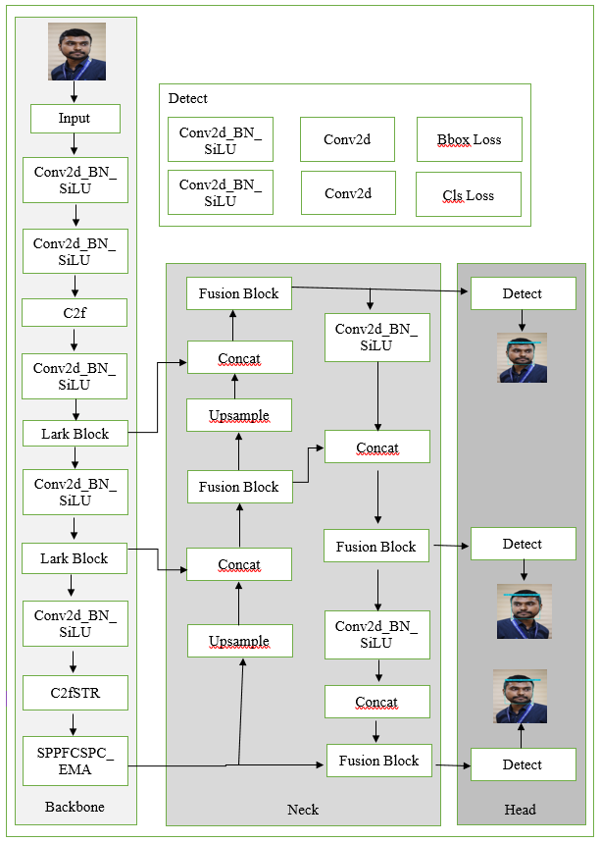
By incorporating these sophisticated approaches, Face-YOLOv8 delivers a strong solution for real-time automatic face detection and recognition in classroom contexts, making it very effective for attendance management systems.
Concat

Figure 12: Proposed Face-YOLOv8 architecture model.

5.3 The Network's Backbone
The backbone of YOLOv8 is intended to effectively extract crucial information from input photos, making it well-suited for face identification in an attendance management system. YOLOv8 utilizes a CSPDarknet-based backbone, which boosts learning efficiency and decreases computing cost. The backbone comprises of numerous convolutional layers, residual connections, and spatial pyramid pooling layers to collect multi-scale face information.

The CSP (Cross-Stage Partial) network separates feature extraction into two channels, enhancing gradient flow and eliminating redundancy. Additionally, the YOLOv8 backbone features the ELAN (Efficient Layer Aggregation Network) module, which improves information flow between layers and boosts feature representation. This structure enables the model to learn rich face characteristics essential for effective detection and identification in the class attendance system.

5.4 The Network of the Neck
The neck network in YOLOv8 plays a significant role in improving the characteristics retrieved by the backbone. It assists in merging and strengthening these characteristics for improved face identification and recognition. The neck incorporates extra convolutional layers, feature fusion algorithms, and skip connections to maintain essential spatial information. It also leverages a Path Aggregation Network (PAN) to boost multi-scale feature learning. This helps the model to recognize faces of varied sizes with improved accuracy. Additionally, YOLOv8 adds a Spatial Pyramid Pooling-Fast (SPPF) module, which helps collect features at multiple sizes, boosting the model’s resilience and detection efficiency.

5.5 The Head Network
The head or prediction layer in YOLOv8 is responsible for identifying and recognizing faces in pictures by predicting bounding boxes, class labels, and confidence scores. This layer takes the improved characteristics from the neck network and applies detection at several scales to enable accurate face identification, even for tiny or obscured faces. The head network performs anchor-free detection, meaning it directly predicts the object’s location without depending on preset anchor boxes, enhancing detection accuracy. Additionally, post-processing methods such as non-maximum suppression (NMS) assist reduce duplicate bounding boxes, ensuring that only the most accurate face detections are kept.
In summary, the backbone captures facial characteristics, the neck refines and integrates them, and the head network creates the final predictions, guaranteeing accurate and efficient face identification in the YOLOv8 model for class attendance management.

5.6 The Face-YOLOv8 Model Algorithm
Algorithm 1: The Proposed YOLOv8 Face Detection Model Algorithm (Pseudo Code)

Input:
- B: Initial detection boxes
- C: Corresponding detection confidence scores
- T: Non-Maximum Suppression (NMS) threshold
Output:
- D: List of final detection boxes

- D = [] # Initialize an empty list for final face detection boxes
- While B is not empty Do
- m = argmax(C) # Find the index of the detection box with the highest confidence score
- b = B[m] # Select the face detection box with the highest confidence score
- D.append(b) # Add the selected box to the final detection list
- B.remove(b) # Remove the selected box from B
- C.remove(C[m]) # Remove the corresponding confidence score from C
- For b' in B Do # Iterate over the remaining detection boxes
- If IoU(b, b') >= T Then # Check the overlap between the selected box and other boxes
- B.remove(b') # Remove overlapping boxes
- End For
- End While
- Return D # Return the final list of detected face bounding boxes

Chapter  6 | RESULT & DISCUSSION

6.1 Experiments in Training
The Face-YOLOv8 model was built using the Python-based Anaconda software framework. The training tests were done on a 64-bit Windows 10 machine with 128 GB of RAM, and an 11 GB NVIDIA GeForce GTX 1080 Ti GPU was employed to expedite the training process.

The YOLOv8 model was trained for automated face detection and identification to enhance class attendance management. The training was conducted utilizing a facial dataset including labeled face photos coupled with annotation files defining the face class information. A modified "yaml" class file and pre-trained learning weights were applied to boost model efficiency.

The model was trained for 50 epochs with a learning rate of 0.0001 and a batch size of 32. To improve the model's performance, the stochastic gradient descent (SGD) optimizer was utilized. This training technique allows the YOLOv8 model to learn face characteristics efficiently and enhance identification accuracy.

6.2 Proposed Model Evaluation Matrices
To assess the performance of the Face-YOLOv8 model for automated face detection and identification, the following important metrics are used:
1. Precision (P) – Measures how many of the recognized faces are genuinely right. It is determined as:
$$Precision(p)=\frac{TP}{TP+FP}$$2. Recall (R) / Sensitivity – Measures how many real faces were accurately recognized by the model. It is supplied by:
$$Sensitivity/Recall(R)=\frac{TP}{TP+FN}$$

3. F1-score (Fs) – A compromise between accuracy and recall, ensuring that both false positives and false negatives are evaluated. It is computed as:
$$F1-score=\frac{(2×TP)}{(2×TP+FN+FP)}$$4. Mean Average Precision (mAP) – A critical parameter for object identification algorithms, which determines the average accuracy across various recall levels. It is calculated as:
$$mAP=\sum_{i=1}^{N}{P(i)×ΔR(i)}$$
Where TP (True Positives) refers to properly detected faces, FP (False Positives) are erroneously detected faces, FN (False Negatives) are missed faces, and P(i) and ΔR(i) indicate precision and recall fluctuations over detections.
These measures guarantee that the YOLOv8 model successfully identifies and recognizes faces, boosting the accuracy and reliability of the attendance management system.

6.3 Training and Testing Performance Analysis
The suggested Face-YOLOv8 model was developed, trained, and evaluated using the obtained face dataset. The model displayed improved performance compared to earlier YOLO models and other state-of-the-art face identification algorithms in both static photos and real-time video streams.

The precision, recall, and P×R curve are depicted in Figure 13. The accuracy curve demonstrated that precision began lower but rapidly increased as training went. As illustrated in Figure 13(a), the suggested Face-YOLOv8 model achieved high precision in detecting and identifying faces, guaranteeing precise attendance monitoring.

Similarly, the recall curve, shown in Figure 13(b), demonstrated that the model effectively recognized faces with a high recall rate, indicating it accurately identified most faces contained in the photos or videos.

The P×R curve, displayed in Figure 13(c), illustrates the model’s efficacy in discriminating distinct faces with enhanced accuracy. These findings reveal that the proposed Face-YOLOv8 model works well in real-world attendance management settings by delivering accurate and reliable face identification.

6.4 Face Classification and Detection Performances
The Face-YOLOv8 model was assessed using the provided test dataset and real-time video frames. For better understanding, multiple analyzed image examples with their detection confidence ratings are shown in Figure 14.
Figure 14 clearly demonstrates that the model accurately identifies faces by delineating them with rectangular bounding boxes and providing detection confidence ratings. The model was further assessed using real-time video footage to evaluate its performance in practical situations. The results demonstrated that the Face-YOLOv8 model effectively detects and recognizes faces with great precision, making it well-suited for automated class attendance monitoring.
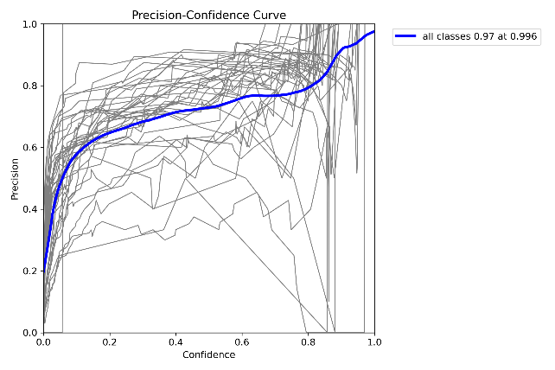  (a) | 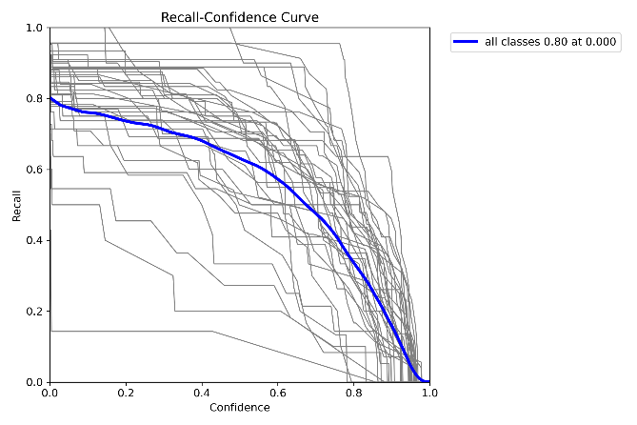  (b)
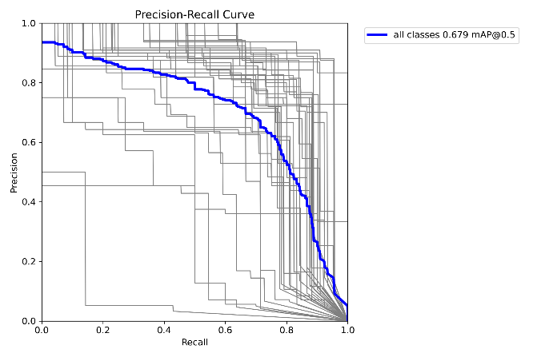  (c) | 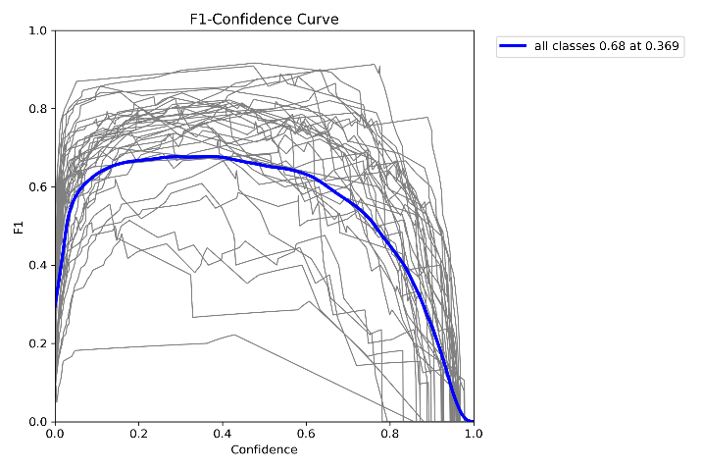  (d)

Figure 13: Training results- (a) Precision, (b) Recall, (c) P×R, (d) F1

The suggested Face-YOLOv8 model effectively recognized faces in video frames with bounding boxes, guaranteeing dependable real-time performance. Additionally, the model correctly identified each individual's face and registered attendance appropriately.
The confusion matrix for the proposed model is presented in Figure 15, indicating its capacity to recognize and categorize faces with high accuracy. However, several misclassifications occurred, such as improper detection of similar-looking persons, which resulted in false positives. An example of this misclassification is provided in Figure 16.

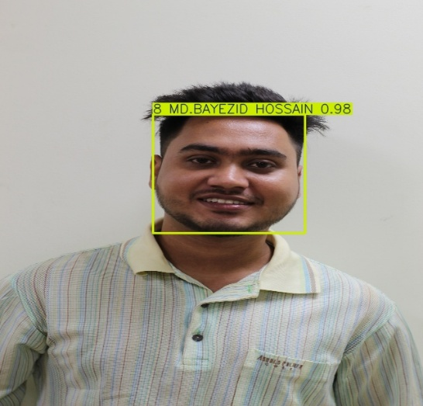  (a) | 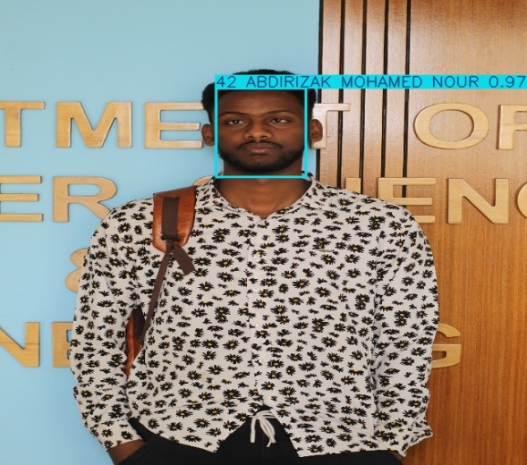  (b)
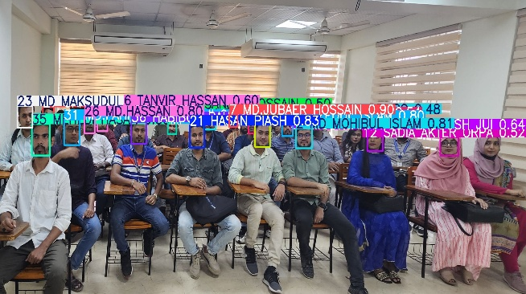  (c) | 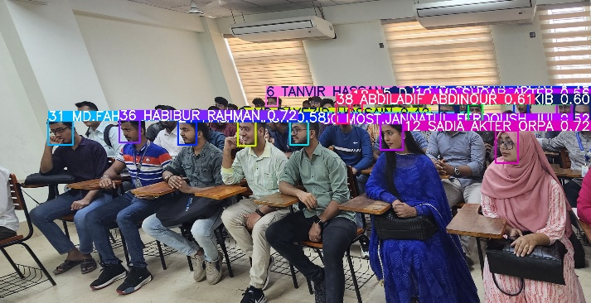  (d)

Figure 14: Face detection and classification results of YOLOv8 model – Detected Single image (a & b) And Detected Group image(c & d)

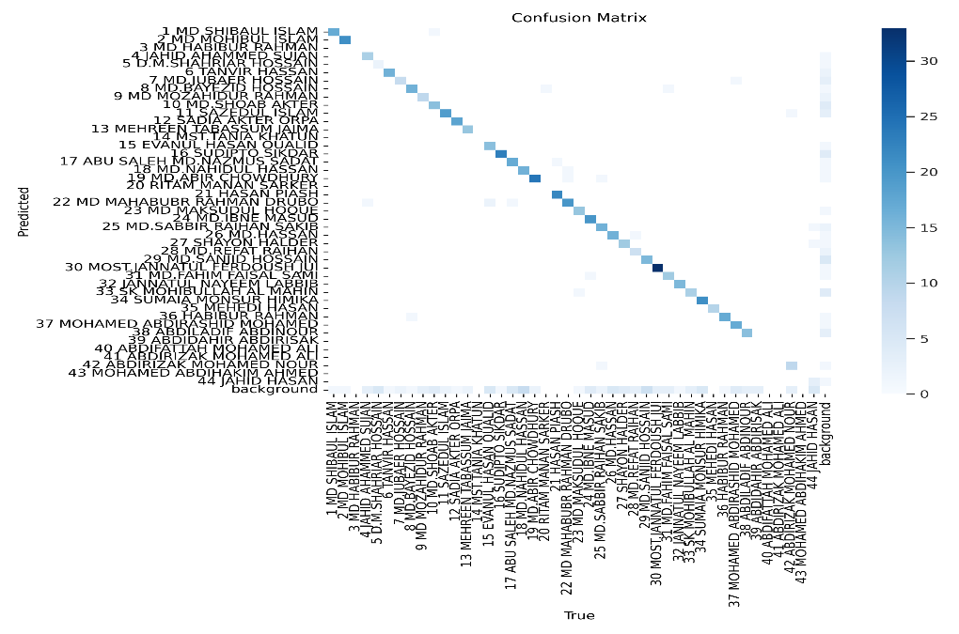
(a)
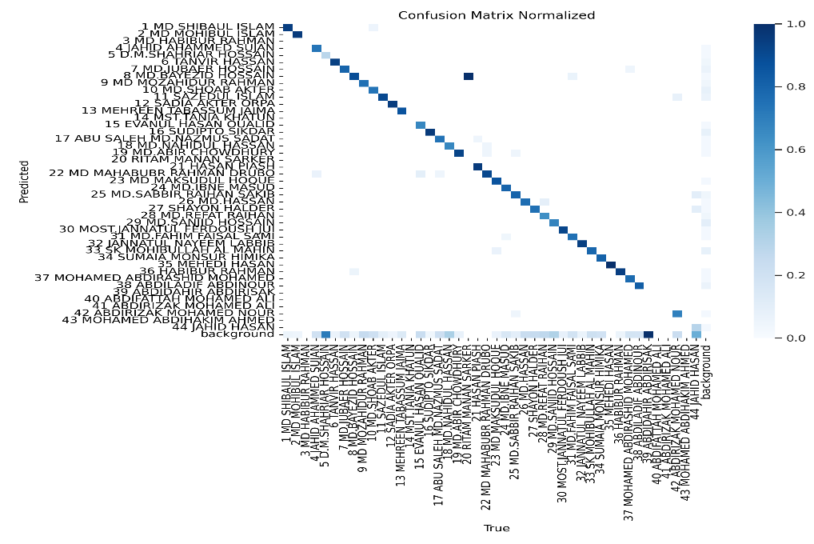
(b)

Figure 15: (a) Confusion matrix & (b) Confusion matrix Normalized

The confusion matrix is an important tool for assessing the performance of the proposed Face-YOLOv8 model in automated face recognition and identification for class attendance management. It helps test the model's validity by comparing predicted identities with the actual labels in the dataset.
In the confusion matrix, each row represents the true identity of a student, whereas each column represents the anticipated identity. If the model properly identifies a student, it is recorded as a True Positive (TP). If the model accurately discovers that a person is not in the dataset, it is a True Negative (TN). A False Positive (FP) emerges when the model wrongly recognizes an absent student as present, whereas a False Negative (FN) occurs when the model fails to detect a present student.
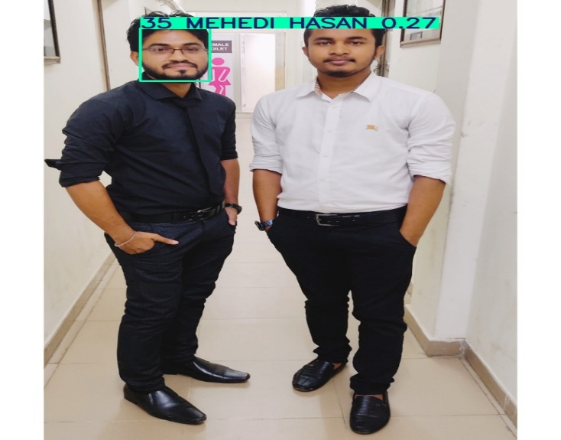
Figure 15 displays the confusion matrix for the proposed Face-YOLOv8 model, displaying its capacity to accurately categorize pupils. The statistics reveal that the model reached high recognition accuracy, with individual student faces being recognized with 100% accuracy. Other classes showed identification accuracy ranging from 94% to 98%, confirming the model's great potential to distinguish amongst pupils. However, several misclassifications occurred owing to students having similar facial characteristics or changes in lighting settings. To analyze the model's success, we applied four essential performance metrics: 1. Precision (P): Measures the fraction of precisely recognized faces among all detected faces. 2. Recall (R): Assesses how many actual student faces were correctly identified. 3. F1-score (F1): Provides a balanced measure of accuracy and recall. 4. Mean Average Precision (mAP): Represents the overall detection and recognition performance.
Figure 16: False positive detecting results by the YOLOv8 model, where one detected as another name from a still image and the other one couldn’t detect face

Chapter  7 | CONCLUSION & FUTURE WORK

7.1 Conclusion
This research provides an autonomous face identification and recognition system for class attendance management using the YOLOv8 deep learning-based model. The suggested methodology accurately identifies and recognizes student faces in real-time, providing an efficient and frictionless attendance procedure. YOLOv8, with its enhanced design and optimized layers, boosts detection accuracy and processing performance. A labeled face dataset was employed, with 80% allocated for training and 20% for testing, producing good accuracy, precision, and recall. The solution eliminates human work, decreases attendance fraud, and simplifies record-keeping for educational institutions. However, problems like recognising shifting lighting conditions and occlusions may impair accuracy, which may be addressed with a bigger and more varied dataset in future study. This method has the potential to revolutionize attendance management, making it more efficient and dependable in academic institutions.

7.2 Future Work
In the future, we will concentrate on enhancing the accuracy of face detection and identification by refining the deep learning model architecture and implementing advanced facial recognition algorithms. Since false positive and false negative findings may arise owing to differences in illumination, occlusions, or insufficient data samples, we will gather a broad and wide dataset to boost model performance in our future study.

Additionally, to make attendance management more effective and smooth, we want to connect real-time face recognition with cloud-based storage. This would allow institutions to store and retrieve attendance data remotely, guaranteeing improved scalability and security. Furthermore, we will study the deployment of anti-spoofing technologies to avoid fraudulent attendance marking utilising printed images or digital displays.

For greater application, we want to implement our system in different educational institutions, business offices, and government entities with adequate coordination with educational boards and IT departments. This study will contribute to the automation and digital transformation of attendance systems, leading to a more secure and efficient management process in Bangladesh.

References

[1] Jalil, Md Abdul, and Md Tuhin Mia. “The Role of Padma Multipurpose Bridge in the National Sustainable Development in Bangladesh.” Journal of Asian and African Social Science and Humanities 7.1 (2021): 38-53.

[2] O. Masurekar, O. Jadhav, P. Kulkarni, and S. Patil, "Real time object detection using YOLOv3," International Research Journal of Engineering and Technology (IRJET), vol. 7, pp. 3764-3768, 2020.

[3] R. A. Hadi, G. Sulong, and L. E. George, "Vehicle detection and tracking techniques: a concise review," arXiv preprint arXiv:1410.5894, 2014.

[4] X. Wang, S. Wang, J. Cao, and Y. Wang, "Data-driven based tiny-YOLOv3 method for front vehicle detection inducing SPP-net," IEEE Access, vol. 8, pp. 110227-110236, 2020.

[5] A. Farid, F. Hussain, K. Khan, M. Shahzad, U. Khan, and Z. Mahmood, "A Fast and Accurate Real-Time Vehicle Detection Method Using Deep Learning for Unconstrained Environments," Applied Sciences, vol. 13, p. 3059, 2023.

[6] A. Hossain, M. T. Islam, and A. F. Almutairi, "A deep learning model to classify and detect brain abnormalities in portable microwave based imaging system," Scientific Reports, vol. 12, p. 6319, 2022.

[7] R. Kaur and J. Singh, "Local Regression Based Real-Time Traffic Sign Detection using YOLOv6," in 2022 4th International Conference on Advances in Computing, Communication Control and Networking (ICAC3N), 2022, pp. 522-526.

[8] U. Mittal, R. Potnuru, and P. Chawla, "Vehicle detection and classification using improved faster region based convolution neural network," in 2020 8th international conference on reliability, Infocom technologies and optimization (trends and future directions)(ICRITO), 2020, pp. 511-514.

[9] G. Satyanarayana, P. Deshmukh, and S. K. Das, "Vehicle detection and classification with spatio-temporal information obtained from CNN," Displays, vol. 75, p. 102294, 2022.

[10] J. Zhao, S. Hao, C. Dai, H. Zhang, L. Zhao, Z. Ji, et al., "Improved vision-based vehicle detection and classification by optimized YOLOv4," IEEE Access, vol. 10, pp. 8590-8603, 2022.

[11] X. Dong, S. Yan, and C. Duan, "A lightweight vehicles detection network model based on YOLOv5," Engineering Applications of Artificial Intelligence, vol. 113, p. 104914, 2022.

[12] Ren, Shaoqing, et al. "Faster r-cnn: Towards real-time object detection with region proposal networks." Advances in neural information processing systems. 2015.

[13] Girshick, Ross. "Fast r-cnn." Proceedings of the IEEE international conference on computer vision. 2015.

[14] J. Redmon and A. Farhadi, “YOLOv3: An Incremental Improvement,” arXiv Prepr., 2018

[15] S. Ding, F. Long, H. Fan, L. Liu, and Y. Wang, “A novel YOLOv3-tiny network for unmanned airship obstacle detection,” IEEE 8th Data Driven Control Learn. Syst. Conf. DDCLS, pp. 277–281, 2019, doi: 10.1109/DDCLS.2019.8908875.

[16] A-Target-Detection-Model-Based-on-Improved-Under-of-Xiao-Shan/c1bb966dc6d3b103988605e46f1ee2318bcdad1c

[17] S. Woo, J. Park, J.-Y. Lee, and I.-S. Kweon, ‘‘CBAM: Convolutional block attention module,’’ in Proc. Eur. Conf. Comput. Vis. (ECCV), 2018, pp. 3–19.

[18] L. Xie and C. Huang, ‘‘A residual network of water scene recognition based on optimized inception module and convolutional block attention module,’’ in Proc. 6th Int. Conf. Syst. Informat. (ICSAI), Shanghai, China, Nov. 2019, pp. 1174–1178.

[19] De Carvalho, O.L.F.; de Carvalho Júnior, O.A.; de Albuquerque, A.O.; Santana, N.C.; Guimarães, R.F.; Gomes, R.A.T.; Borges, D.L. Bounding box-free instance segmentation using semi-supervised iterative learning for vehicle detection. IEEE J. Sel. Top. Appl. Earth Obs. Remote Sens. 2022, 15, 3403–3420.

[20] 367317170_YOLO-HR_Improved_YOLOv5_for_Object_Detection_in_High-Resolution_Optical_Remote_Sensing_Images

[21]363824867_A_comparative_study_of_YOLOv5_models_performance_for_image_localization_and_classification

[22] 368849613_Real-world_application_of_face_mask_detection_system_using_YOLOv6

[23] A. D. Bank. (2023, 01/04/2023). Bangladesh Signs Intelligent Transport System Project under SASEC. Available: https://www.sasec.asia/index.php?page=news&nid=1375&url=ban-signs-its-sasec

[24] ieeexplore.ieee.org/stamp/stamp.jsp?arnumber=9446998

[25] J. Redmon, S. Divvala, R. Girshick, and A. Farhadi, "You only look once Unified, real-time object detection," in Proceedings of the IEEE conference on computer vision and pattern recognition, 2016, pp. 779-788.

[26] C.-Y. Wang, A. Bochkovskiy, and H.-Y. M. Liao, "YOLOv7: Trainable bag-of-freebies sets new state-of-the-art for real-time object detectors," arXiv preprint arXiv:2207.02696, 2022.

[27] J. Redmon. (2023, 01/04/2023). YOLOv7: The Most Powerful Object Detection Algorithm. Available: https://viso.ai/deep-learning/yolov7-guide/

[28] Zhang, X., Zeng, H., Guo, S., Zhang, L. (2022). Efficient long-range attention network for image super-resolution. Comput. Vision Pattern recognition. doi: 10.1007/978-3-031-19790-1_39
[29] Subedi, Sachin, et al. "Tracking floor eggs with machine vision in cage-free hen houses." Poultry Science 102.6 (2023): 102637.
[30] A. Hossain, M. T. Islam, S. K. Abdul Rahim, M. A. Rahman, T. Rahman, H. Arshad, et al., "A Lightweight Deep Learning Based Microwave Brain Image Network Model for Brain Tumor Classification Using Reconstructed Microwave Brain (RMB) Images," Biosensors, vol. 13, p. 238, 2023.

[31] A. Hossain, M. T. Islam, T. Rahman, M. E. Chowdhury, A. Tahir, S. Kiranyaz, et al., "Brain Tumor Segmentation and Classification from Sensor-Based Portable Microwave Brain Imaging System Using Lightweight Deep Learning Models," Biosensors, vol. 13, p. 302, 2023.

[32] YOLO-v1 to YOLO-v8, the Rise of YOLO and Its Complementary Nature toward Digital Manufacturing and Industrial Defect Detection.

[33] VisionICE_Air-Ground_Integrated_Intelligent_Cognit yolo 7

[34] Extracting Objects’ Spatial–Temporal Information Based on Surveillance Videos and the Digital Surface Model

[35] Deep Learning-based Trajectory Estimation of Vehicles in Crowded and Crossroad Scenarios

[36] CombiningtheYOLOv4DeepLearningModelwithUAVImagery Processing Technology in the Extraction and Quantization of Cracks in Bridges

[37] YOLO v3-Tiny: Object Detection and Recognition using one stage improved model

